**CYBER FORZA**

A reference document used for How Implement *Views* in Nagios

Revision: Draft specification 1.0

July 2017

**Cyber Forza Inc. Confidential and Proprietary**

Copyright © 2017, Cyber Forza Incorporation. All rights reserved.

This document contains information that is considered proprietary and the property of Cyber Forza Inc. The content of this document may not be used in any way, duplicated, or distributed by any means without the express written permission of Cyber Forza Inc

Unless otherwise agreed in writing, by Cyber Forza Inc., The Cyber Forza products are not designed or intended for any application in which the failure of the product could create a situation where personal injury or death may occur.

Cyber Forza Inc. may change specifications and product description at any time, without notice.

Contact Cyber Forza Inc. to obtain latest specification.

# Contents

1 [1 Revision History](#_1_Revision_History)……………………………………………………………….…….4

[2 Quick Start Guide](#_2_Quick_Start) ……………………………………………………………….…… 5

[2.1 System Specification](#_2.1_System_Specification)….………………………………………………………… … 5

[2.2 Support Information](#_2.2__Support)...…………………………………....…………………………5

[2.3 Getting Started](#_2.3__Getting)………………………………….………….………………………. 5

[2.4 Definitions](#_2.4_Definitions)…………………………………………………………………………...5

[3 How accomplished the Nagios's "view" privileges](#_3_How_accomplished)…………………………………..8

|  |  |  |
| --- | --- | --- |
| Date | Revision No. | Description |
| 12/07/17 | Draft Release 1.0 | Initial version |
|  |  |  |

# 1 Revision History

# 2 Quick Start Guide

# 2.1 System Specification

*Table 1: System Configuration*

|  |
| --- |
| * Ubuntu 16.04.1 LTS (Linux Kernel 4.4) |
| * System RAM: 3911776 KB |
| * Hard Disk space: 21.1 GB |
| * OS type: 64-bit |
| * Memory: 3.7 GiB |
| * Processor: Intel Core 2 Duo CPU E8400 @ 3.00GHz x 2 |

# 2.2 Support Information

* Please contact the Cyber Forza Inc. team for support

# 2.3 Getting Started

This documentation describes how the Nagios CGIs decide who has access to view monitoring and configuration information, and who can submit commands to the Nagios daemon through the web interface.

# 

# 2.4 Definitions

Before continuing, it is important that you understand the meaning of and difference between authenticated users and authenticated contacts:

* An **authenticated user** is an someone who has authenticated to the web server with a username and password and has been granted access to the Nagios web interface.
* An **authenticated contact** is an authenticated user whose username matches the short name of a contact definition.

**Setting Up Authenticated Users**

Assuming you configured your web server, it should require that you authenticate before accessing the Nagios CGIs. You should also have one user account (*nagiosadmin*) that can access the CGIs.

As you define more contacts  for receiving host and service notifications, you'll most likely want to let them access the Nagios web interface. You can use the following command to add additional users who can authenticate to the CGIs. Replace <username> with the actual username you want to add. In most cases, the username should match the short name of a contacts that has been defined.

htpasswd /usr/local/nagios/etc/htpasswd.users <username>

**Enabling Authentication/Authorization Functionality In The CGIs**

The next thing you need to do is make sure that the CGIs are configured to use the authentication and authorization functionality in determining what information and/or commands users have access to. This is done be setting the [use\_authentication](https://assets.nagios.com/downloads/nagioscore/docs/nagioscore/3/en/configcgi.html#use_authentication) variable in the [CGI configuration file](https://assets.nagios.com/downloads/nagioscore/docs/nagioscore/3/en/configcgi.html) to a non-zero value. Example:

use\_authentication=1

Okay, you're now done with setting up basic authentication/authorization functionality in the CGIs.

**Default Permissions To CGI Information**

|  |  |  |
| --- | --- | --- |
| CGI Data | Authenticated Contacts[\*](https://assets.nagios.com/downloads/nagioscore/docs/nagioscore/3/en/cgiauth.html#definitions) | Other Authenticated Users[\*](https://assets.nagios.com/downloads/nagioscore/docs/nagioscore/3/en/cgiauth.html#definitions) |
| Host Status Information | Yes | No |
| Host Configuration Information | Yes | No |
| Host History | Yes | No |
| Host Notifications | Yes | No |
| Host Commands | Yes | No |
| Service Status Information | Yes | No |
| Service Configuration Information | Yes | No |
| Service History | Yes | No |
| Service Notifications | Yes | No |
| Service Commands | Yes | No |
| All Configuration Information | No | No |
| System/Process Information | No | No |
| System/Process Commands | No | No |

Table 2 Permissions do users have in the CGIs by default when the authentication/authorization functionality is enabled

*Authenticated contacts*[*\**](https://assets.nagios.com/downloads/nagioscore/docs/nagioscore/3/en/cgiauth.html#definitions) are granted the following permissions for each **service** for which they are contacts (but not for services for which they are not contacts)...

* Authorization to view service status information
* Authorization to view service configuration information
* Authorization to view history and notifications for the service
* Authorization to issue service commands

*Authenticated contacts*[*\**](https://assets.nagios.com/downloads/nagioscore/docs/nagioscore/3/en/cgiauth.html#definitions) are granted the following permissions for each **host** for which they are contacts (but not for hosts for which they are not contacts)...

* Authorization to view host status information
* Authorization to view host configuration information
* Authorization to view history and notifications for the host
* Authorization to issue host commands
* Authorization to view status information for all services on the host
* Authorization to view configuration information for all services on the host
* Authorization to view history and notification information for all services on the host
* Authorization to issue commands for all services on the host

It is important to note that by default **no one** is authorized for the following...

* Viewing the raw log file via the [showlog CGI](https://assets.nagios.com/downloads/nagioscore/docs/nagioscore/3/en/cgis.html#showlog_cgi)
* Viewing Nagios process information via the [extended information CGI](https://assets.nagios.com/downloads/nagioscore/docs/nagioscore/3/en/cgis.html#extinfo_cgi)
* Issuing Nagios process commands via the [command CGI](https://assets.nagios.com/downloads/nagioscore/docs/nagioscore/3/en/cgis.html#cmd_cgi)
* Viewing host group, contact, contact group, time period, and command definitions via the [configuration CGI](https://assets.nagios.com/downloads/nagioscore/docs/nagioscore/3/en/cgis.html#config_cgi)

**Granting Additional Permissions To CGI Information**

You can grant *authenticated contacts* or other *authenticated users* permission to additional information in the CGIs by adding them to various authorization variables in the [CGI configuration file](https://assets.nagios.com/downloads/nagioscore/docs/nagioscore/3/en/configcgi.html). The available options don't allow for getting really specific about particular permissions, but its better than nothing..

Additional authorization can be given to users by adding them to the following variables in the CGI configuration file...

* [authorized\_for\_system\_information](https://assets.nagios.com/downloads/nagioscore/docs/nagioscore/3/en/configcgi.html#authorized_for_system_information)
* [authorized\_for\_system\_commands](https://assets.nagios.com/downloads/nagioscore/docs/nagioscore/3/en/configcgi.html#authorized_for_system_commands)
* [authorized\_for\_configuration\_information](https://assets.nagios.com/downloads/nagioscore/docs/nagioscore/3/en/configcgi.html#authorized_for_configuration_information)
* [authorized\_for\_all\_hosts](https://assets.nagios.com/downloads/nagioscore/docs/nagioscore/3/en/configcgi.html#authorized_for_all_hosts)
* [authorized\_for\_all\_host\_commands](https://assets.nagios.com/downloads/nagioscore/docs/nagioscore/3/en/configcgi.html#authorized_for_all_host_commands)
* [authorized\_for\_all\_services](https://assets.nagios.com/downloads/nagioscore/docs/nagioscore/3/en/configcgi.html#authorized_for_all_services)
* [authorized\_for\_all\_service\_commands](https://assets.nagios.com/downloads/nagioscore/docs/nagioscore/3/en/configcgi.html" \l "authorized_for_all_service_commands" \t "_blank)

**CGI Authorization Requirements**

If you are confused about the authorization needed to access various information in the CGIs, read the***Authorization Requirements*** section for each CGI as described [here](https://assets.nagios.com/downloads/nagioscore/docs/nagioscore/3/en/cgis.html).

# 

# 3 How accomplished  the Nagios's  "view" privileges

To accomplished  the Nagios's  "view" privileges over host and services, based in the user login.

We followed these steps:

Created the following users:  
  
*htpasswd /usr/local/nagios/etc/htpasswd.users****user.for.linux***New password: linux  
Re-type new password: linux  
  
  
htpasswd /usr/local/nagios/etc/htpasswd.users **user.for.windows**  
New password: windows  
Re-type new password: windows

In the file ***contact.cfg*** I add the following contacts and contact\_groups  
  
  
*define contact{  
        contact\_name****user.for.windows****; Short name of user  
        use                             generic-contact         ; Inherit default values from generic-contact template (defined above)  
        alias                           Nagios testing privileges to view  windows          ; Full name of user  
  
        email*[*user.for.windows@localhost*](https://box3140.bluehost.com:2096/cpsess5752499595/3rdparty/roundcube/?_task=mail&_caps=pdf%3D1%2Cflash%3D0%2Ctif%3D0&_uid=191&_mbox=INBOX.Sent&_action=show#NOP)*; <<\*\*\*\*\* CHANGE THIS TO YOUR EMAIL ADDRESS \*\*\*\*\*\*  
        }*  
  
  
  
  
*define contactgroup{  
        contactgroup\_name       admins.in.layers.for.windows  
        alias                   Nagios Administrators  In Layers for Windows  
        members****user.for.windows*** *}*  
  
...................  
 *define contact{  
        contact\_name****user.for.linux****; Short n  
ame of user  
        use                             generic-contact         ; Inherit  
 default values from generic-contact template (defined above)  
        alias                           Nagios testing privileges to view  linux          ; Full name of user  
  
        email*[*user.for.linux@localhost*](https://box3140.bluehost.com:2096/cpsess5752499595/3rdparty/roundcube/?_task=mail&_caps=pdf%3D1%2Cflash%3D0%2Ctif%3D0&_uid=191&_mbox=INBOX.Sent&_action=show#NOP)*; <<\*\*\*\*\* CHANGE THIS TO YOUR EMAIL ADDRESS \*\*\*\*\*\*  
        }*

*define contactgroup{  
        contactgroup\_name       admins.in.layers.for.linux  
        alias                   Nagios Administrators  In Layers for Linux  
        members****user.for.linux*** *}*  
  
  
Then make those  the contact of the hosts/services which you want to allow to view in the respective Object:  
  
  
  
*define host{  
        use             windows-server  ; Inherit default values from a template  
        host\_name       winserver       ; The name we're giving to this host  
        alias           My Windows Server       ; A longer name associated with the host  
        address         192.168.50.150  ; IP address of the host  
  
        contacts****user.for.windows*** *contact\_groups  admins.in.layers.for.windows  
        }*  
and for the objet localhost, I did the same:  
  
  
*define host{  
        use                     linux-server            ; Name of host template to use  
                                                        ; This host definition will inherit all variables that are defined  
                                                        ; in (or inherited by) the linux-server host template definition.  
        host\_name               localhost  
        alias                   localhost  
        address                 127.0.0.1  
        contacts****user.for.linux*** *contact\_groups          admins.in.layers.for.linux  
        }*  
  
Restart nagios services, and now when you log as user user.for.linux you will be able to see hosts, services, reports related to it  
  
The same user.for.windows you will be able to see hosts, services, reports related to it  
  
In Figure 1, Figure 2 and Figure 3 you can see the different "views" when the user logged is **user.for linux**, **user.for.windwos** and **nagiosadmin** respectively.

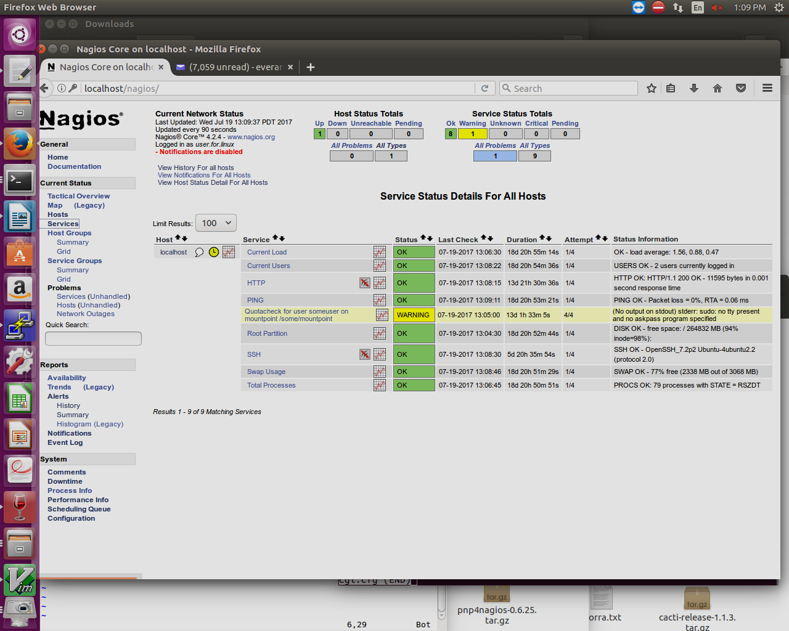

Figure 1: “View” from user ***user.for.linux***

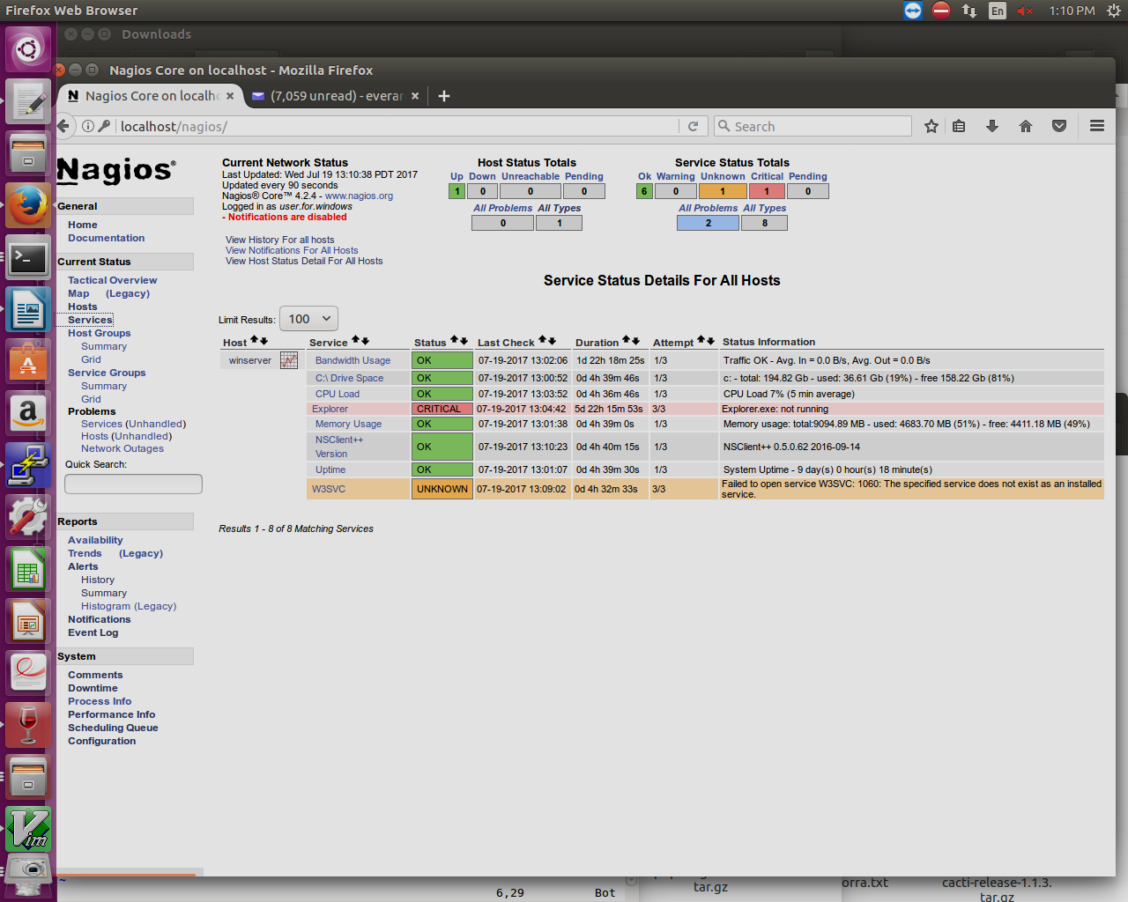

Figure 2: “View” from user ***user.for.windows***

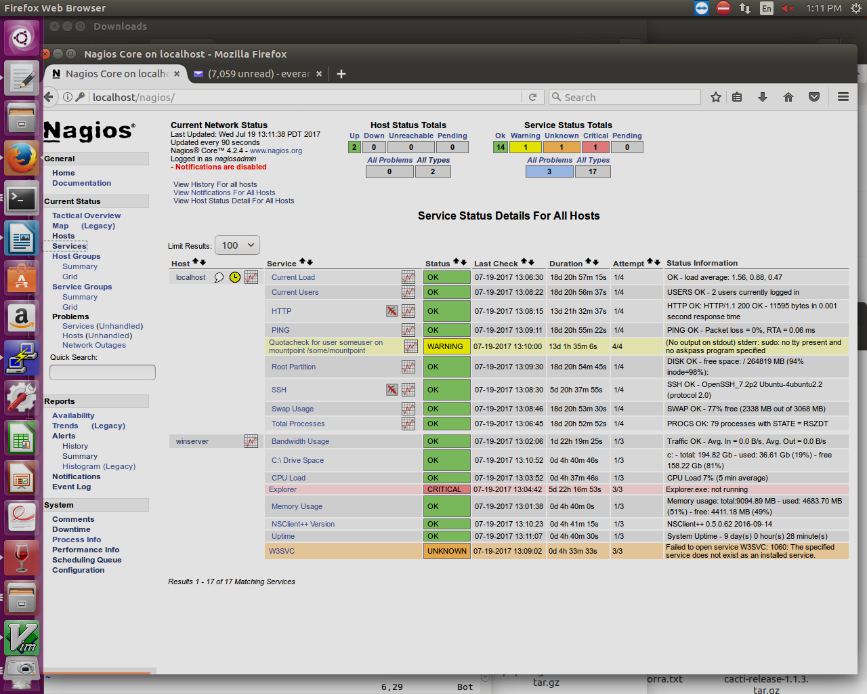

Figure 3: “View” from user ***nagiosadmin***

As is showed in the Table 2 Permissions do users have in the CGIs by default when the authentication/authorization functionality is enabled the users have some privileges for default.  
  
And beside that, by file cgi.cfg by the following variables, we could add those privileges to a specific users, adding it to those item.  
  
  
authorized\_for\_all\_host\_commands=nagiosadmin  
authorized\_for\_all\_hosts=nagiosadmin  
authorized\_for\_all\_service\_commands=nagiosadmin  
authorized\_for\_all\_services=nagiosadmin  
authorized\_for\_configuration\_information=nagiosadmin  
authorized\_for\_system\_commands=nagiosadmin  
authorized\_for\_system\_information=nagiosadmin  
  
:

Because the basic auth  as the credentials are cached, doesn’t exists the  possibility of a log out button in Nagios GUI(Web interface) to log out from *nagiosadmin* user and log in as another usery ou must clear the browser cache to login as a different user.  
  
You could try changing your URL manually to:  
<http://newusername@.../nagios/>  
then, a new http-auth prompt should pop up.

\*\*Note: (Our team is working on in resolve this issue)

Links reference:

https://assets.nagios.com/downloads/nagioscore/docs/nagioscore/3/en/configcgi.html#authorized\_for\_all\_service\_commands